Title [‘Title’, Times New Roman, 16pt, Bold, Centred, Capitalised]
A. Author¹, B. Author², C. Author³ [‘Authors’, Times New Roman, 10pt, Bold, comma separated, centred]
^{1,2} Institute 1 Address [‘Affiliations’, Times New Roman, 10pt, centred]
³ Institute 2 Address [‘Affiliations’, Times New Roman, 10pt, centred]
¹corresponding.author@email.address.ac.uk [‘Email’, Times New Roman, 10pt, Italics, centred]
Keywords: Maximum five keywords, separated by semi-colons [‘Keywords’, Times New Roman, 10pt, centred]

Extended Abstract
Introduction [‘SubHeading’, Times New Roman, 10pt, Capitalised, left justified]
[‘ExtendedAbstract’, Times New Roman, 10pt, Justified, italicised, line spacing single]
Insert the text of the extended abstract here. It should not exceed two pages, including figures, tables and references. You will find a number of specified styles and formats as part of this template: for consistency across the submissions, please stick to these formats. If headings are used within the extended abstract, please only use one level (‘SubHeading’ style). All margins (top, bottom, left and right) should be 2cm.
When submitting your extended abstract, please name the file with the first author’s last name and a number in case you are submitting more than one abstract (e.g. Smith01.doc, Smith02.doc, etc).
Please submit all abstracts following the instructions at https://www.aqua360.net/abstract-submission.

Methods and Materials [‘SubHeading’, Times New Roman, 10pt, Capitalised, left justified]
Figures and tables should be included directly in the document and be described in the body of the text. Table 1 and Figure 1 are examples of Tables and Figures.
Table 1. Some Letters and Numbers [‘Caption’, Times New Roman, 9pt, Italic, centred]
Water quality parameters | Units | Daily average
COD_{in} | mg/L | 225.1
COD_{out} | mg/L | 40.2
BOD_{in} | mg/L | 125.4
BOD_{out} | mg/L | 6.2
TN_{in} | mg/L | 27.6
TN_{out} | mg/L | 11.0

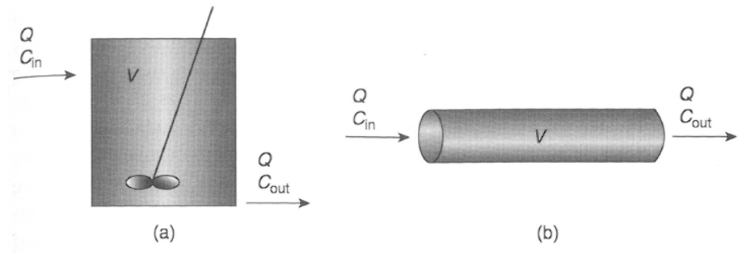
Figure 1. Comparison of (a) Completely Mixed Flow Reactor and (b) Plug-Flow Reactor [1] [‘Caption’, Times New Roman, 9pt, Italic, centred]

Results and Discussion [‘SubHeading’, Times New Roman, 10pt, Capitalised, left justified]
This is an extra paragraph to fill up some space and highlight the formatting style. This paper makes a novel contribution to the field of abstract formatting. Based on the work of the seminal work from past authors [2], and with due reference to the post-modernist, pre-modernist, modern and non-modern schools [3], this article details the advances made by the current authors in the fields of typography, typesetting and good taste [4].
Conclusions [‘SubHeading’, Times New Roman, 10pt, Capitalised, left justified]
This is the template that should be used to format your papers for the AQUA360 conference. Papers that are not submitted in this format will not be accepted.

References
[Times New Roman, 9pt, Left Aligned, ‘References’ format, Numbering following IEEE style]
[1] J. R. Mihelcic and J. B. Zimmerman, Environmental Engineering: Fundamentals, Sustainability, Design, 2nd Edition. Wiley Global Education, 2014.
[2] USEPA, ‘Guidelines for Water Reuse’, United States Environmental Protection Agency (USEPA), Washington D. C., USA, EPA/600/R-12/618, 2012.
[3] ‘Systems Resilience for Multihazard Environments: Definition, Metrics, and Valuation for Decision Making - Ayyub - 2013 - Risk Analysis - Wiley Online Library’. [Online]. Available: http://onlinelibrary.wiley.com/doi/10.1111/risa.12093/full. [Accessed: 26-Feb-2018].
[4] E. C. Dogan, A. Yasar, U. Sen, and C. Aydiner, ‘Water recovery from treated urban wastewater by ultrafiltration and reverse osmosis for landscape irrigation’, Urban Water J., vol. 13, no. 6, pp. 553–568, Aug. 2016, doi: 10.1080/1573062X.2014.992917.

